**Student, Department, Batch, Teacher & Subject Scenario**

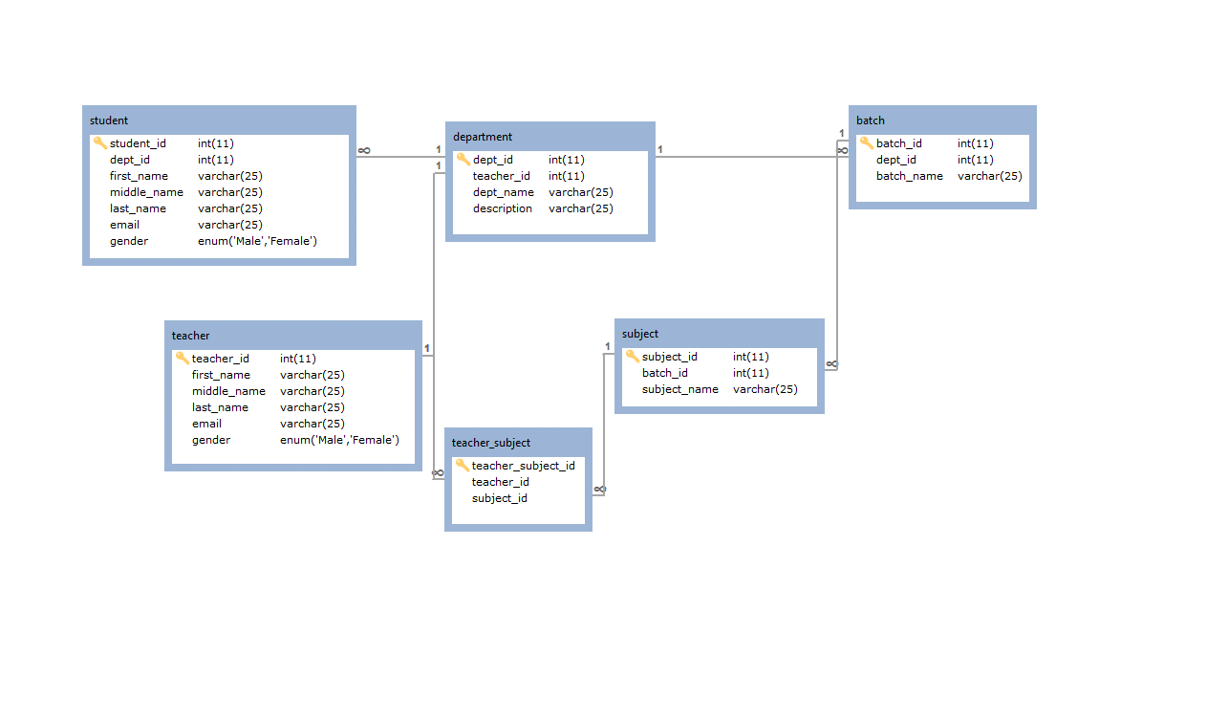

Query #1

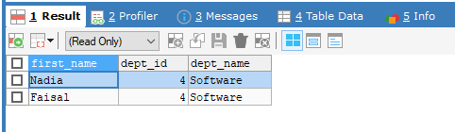

SELECT student.`first_name`, student.`dept_id`, department.`dept_name` FROM student INNER JOIN department ON student.dept_id = department.`dept_id`WHERE department.`dept_name`='Software';

Query #2

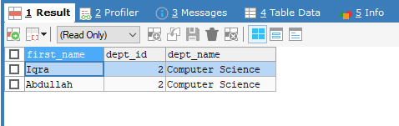

SELECT student.`first_name`, student.`dept_id`, department.`dept_name` FROM student INNER JOIN department ON student.dept_id = department.`dept_id`WHERE student.`dept_id` = 2;

Query #3



SELECT student.`first_name`, batch.`batch_name` FROM student INNER JOIN department ON (student.dept_id = department.`dept_id`) INNER JOIN batch ON (department.`dept_id`=batch.`dept_id`) WHERE student.`first_name`='Ahmed';

Query #4

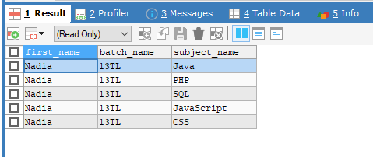

SELECT student.`first_name`, batch.`batch_name`, subjects.`subject_name` FROM student, batch, subjects WHERE student.`student_id`=4 AND batch.`batch_id`= 2;

Query #5

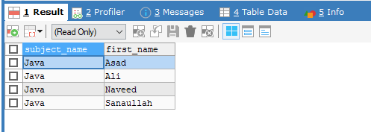

SELECT subjects.`subject_name`, teacher.`first_name` FROM subjects, teacher WHERE subjects.`subject_id`= 1;

Query #6

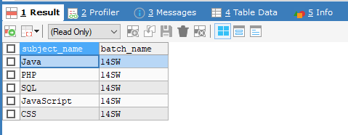

SELECT subjects.`subject_name`, batch.`batch_name` FROM subjects, batch WHERE batch.`batch_id`=1;

Query #7



SELECT subjects.`subject_name`, teacher.`first_name` FROM subjects, teacher WHERE teacher.`first_name`='Ali';

Query #8

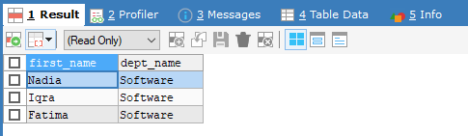

SELECT student.`first_name`, department.`dept_name` FROM student, department WHERE student.`gender`='Female' AND department.`dept_name`='Software';

Query #9

No answer.